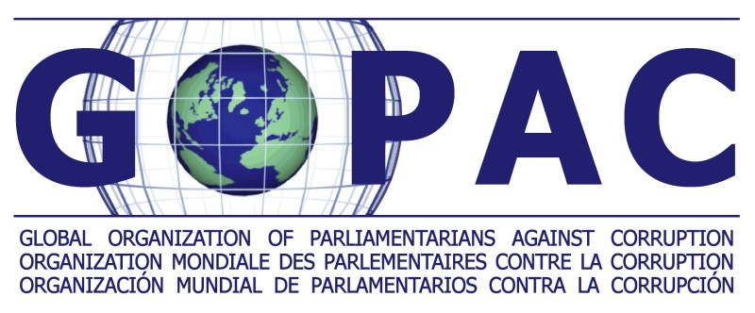

U4-GOPAC Discussion Paper on UNCAC – Article 5, Preventive Anti-Corruption Policies and Practices
Kuwait, November 2008

The very nature of corruption is that it is a political problem and that simple technocratic solutions often lead to superficial intervention – political will is needed to change systems and attitudes and to ensure that policies are used in practice and not just on paper.

This joint U4 and GOPAC discussion paper focuses on Article 5 of the UNCAC – Preventive Anti-Corruption Policies and Practices - which we will refer to in short form as ‘anti corruption policies’. The substance is largely drawn from a recent U4 study as well as consultations with experts and parliamentarians.

In our recent consultations, there appears to be an emerging view among those international agencies working with GOPAC that to be effective, international conventions may benefit from more integrated approaches that engage not only the executive branch of government but also parliamentarians and civil society . This paper presents a case for the involvement of parliamentarians as part of such a more integrated approach as Article 5 does not include a specific reference to the parliamentary engagement in anti-corruption policies, as illustrated in the excerpt below.

Chapter II
Preventive measures
Article 5
Preventive anti-corruption policies and practices

1. Each State Party shall, in accordance with the fundamental principles of its legal system, develop and implement or maintain effective, coordinated anticorruption policies that promote the participation of society and reflect the principles of the rule of law, proper management of public affairs and public property, integrity, transparency and accountability.

2. Each State Party shall endeavour to establish and promote effective practices aimed at the prevention of corruption.

3. Each State Party shall endeavour to periodically evaluate relevant legal instruments and administrative measures with a view to determining their adequacy to prevent and fight corruption.

4. States Parties shall, as appropriate and in accordance with the fundamental principles of their legal system, collaborate with each other and with relevant international and regional organizations in promoting and developing the measures referred to in this article. That collaboration may include participation in international programmes and projects aimed at the prevention of corruption.

The U4 study carried out six country case studies with respect to experiences with national anti-corruption policies and strategies. The following findings bear relevance to parliamentarians.

- Not enough attention has been given to the political dimension of anti-corruption policies, in particular the high level political will that gave birth to these anti-corruption strategies could not be maintained from the beginning to end of the government policy cycle, as well as across changes in governments.

- Most anti-corruption approaches were not strategic, they did not set priorities, nor did they consider sequencing in implementation.
- Monitoring and evaluation has been almost entirely ignored: self-assessments did not bring results and external reviews of progress, e.g. by parliaments, research institutes and universities, had not even been foreseen.
- The lack of information for and communication with implementing agencies, political actors, the media and the public hinders the creation of a sustained political debate and thus political pressure to move anti-corruption policies forward.

The analysis of some key features of policy making can provide some insights into why this happens:

- With regard to national ownership, anti-corruption policies and strategies tend to be concentrated on strengthening the government’s power base and maintaining the status quo. The lack of mechanisms for guaranteeing multi-stakeholder participation throughout the full policy cycle impedes the effectiveness of these anti-corruption efforts.
- In their content, most of the anti-corruption strategies which were studied focus on norms and institutions – with a limited regard for performance and results. The notable mismatch between the political nature of the problem and the technocratic solutions is likely to result in superficial interventions. In addition, envisioned solutions are not based on adequate diagnostics of what causes the problems, and integration with other core governance policies and reforms hardly takes place in practice.
- In terms of implementation, coordination and monitoring, it is particularly worrisome to note that this crucial phase of the policy cycle does not receive sufficient political and operational attention. Leadership and oversight are often characterised by a mismatch between limited institutional capacities and too ambitious objectives. Also, it is not clear how an approach of self-reform through self-assessment is supposed to work, in particular when taking into account that institutions in general tend to resist change. Last but not least, the lack of meaningful participatory monitoring and evaluation seems to convert anti-corruption policies into paper tigers.

The U4 study concludes that corruption might be addressed directly or indirectly through many different policy options. The direct anti-corruption approach might not always be suitable and promoting widely accepted antidotes to corruption such as transparency and accountability – e.g. through strengthened parliamentary oversight – might promise greater impact, especially in countries where corruption is endemic. Above all, it is of great importance to recognise the need to build high-level political agreements and achieve a national consensus in order to develop a strategic vision about how to fight corruption.
Based on these findings, three main areas of anti-corruption policy making emerge for parliamentarians to play a role in:
- if these country anti-corruption policies were developed more openly and tailored or domesticated to specific national reform needs, it would help ensure aligning proposed improvements with the country context and public values, an approach that could reduce resistance to changes and engage more stakeholders. Success of reform will in this regard depend as mentioned above on achieving high-level political agreements and a national consensus – both processes bear considerable potential for parliamentary involvement;
- if parliaments and their respective committees were involved more in the design of such policies, they could ensure keeping realistic goals and consistency with allocating the necessary budgetary resources to the proposed reform steps. After all, implementation is often hampered by capacity and resource constraints; and
- increasing the involvement of parliamentarians not only in the design, but especially in the oversight of implementing anti-corruption polices could help maintain a continuing political focus, most of all when governments change, and help ensure monitoring of results. Such review of anti-corruption policies in the parliament or in parliamentary committees would also provide for greater accountability of the executive to parliaments and the public and could contribute to any future review mechanism installed by the Conference of State Parties to UNCAC. (See Annex 2 for a briefing note for GOPAC members on review mechanisms.)

Potential next steps: for discussion
In terms of next steps, GOPAC members could explore and discuss among themselves what approaches would work best or do not in their respective regions or countries. They could discuss what types of initiatives are needed to ensure that the country’s approach to address the specific corruption issues of the nation is doable in a practical way.
More specifically, GOPAC members and others could:
- encourage parliamentary engagement and open processes to review the anti-corruption policies, to promote, among other things, societal learning and credibility by assigning the process to a parliamentary committee;
- play an active role in building a national consensus for anti-corruption reform;
- encourage the setting of specific priorities and staged implementation given that the UNCAC is very broad and not everything can be done at once;
- raise awareness that parliaments and parliamentarians, as instruments of good governance, can play an important role in the development, implementation and monitoring of country anti-corruption policies;

- explore and highlight good practices where parliamentarians have played a role in the life cycle of an anti-corruption strategy or approach, for example, where there has been political discussion in setting priorities, in particular how more generic approaches were adapted or domesticated to better align with a country’s institutions, culture and values;
- work closely with international agencies to ensure GOPAC initiatives are based on sound empirical studies and evidence;
- train parliamentarians on the different anti-corruption policies or approaches a country can take in combating corruption or other initiatives; and
- encourage regional and national chapters to examine anti-corruption policies and the issues around them.

Hussmann, K. Editor. U4. Anti-corruption policy making in practice: What can be learned for the implementation of Article 5 of the UNCAC? Dec. 2007
Discussions were held with WBI, OECD, TI, UNODC and UNDP in September 2008.
Hussmann, page viii
Examples of policy approaches could include: explicit broad national frameworks; explicit policies on improving accountability or other areas; embedding anti-corruption in broader public service reforms; or legislative agendas.
Hussmann, p. x

